Use of the Spectrophotometer

http://www.youtube.com/watch?v=PnaNUINj9Eo

Explain how to use the spectrophotometer. In the parentheses, indicate which part of the machine you adjust at each step (A, B, C, etc).

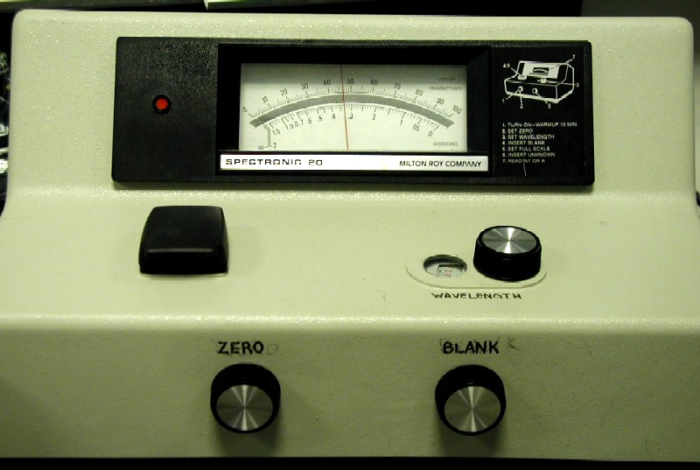
A

B
C
E

D

Step 1: _____________________________________________________ ( ______)

Step 2: _____________________________________________________ ( ______)

Step 3: _____________________________________________________ ( ______)

Step 4: _____________________________________________________ ( ______)

Step 5: _____________________________________________________ ( ______)

Step 6: ____________Take your reading___________________________ ( A )

The bottom scale shows you the _________________________ and the top scale shows you the _____________________________.

What is the purpose of the blank?

