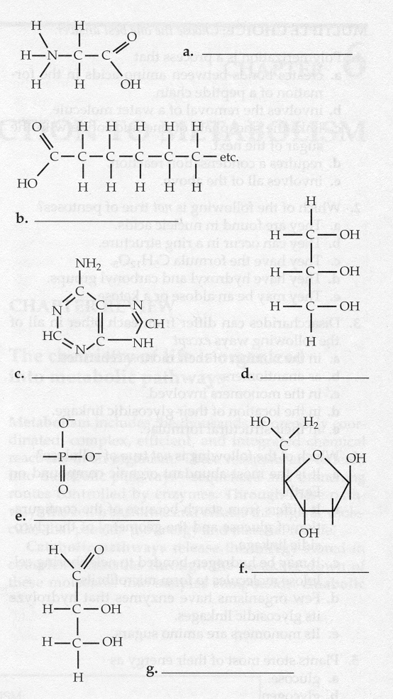
Review 1

- What are some of the unique properties of water that make life on earth possible?

- Name the biomolecules seen here.

- Name the functional groups and describe some of the important properties of each molecule.

- How do cells synthesize and break down macromolecules?

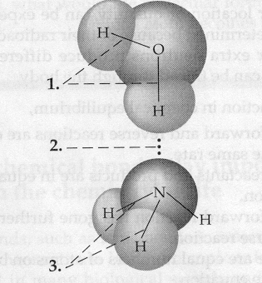

- Label the bonds.

- Compare and contrast prokaryotic and eukaryotic cells.
Prokaryote Eukaryote

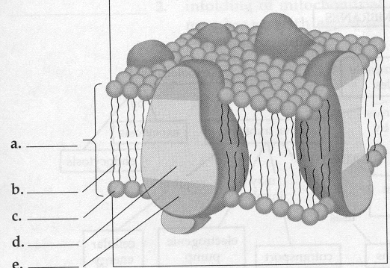

- Describe the fluid-mosaic model of the cell membrane:

- How do membranes of different cells differ structurally and functionally?

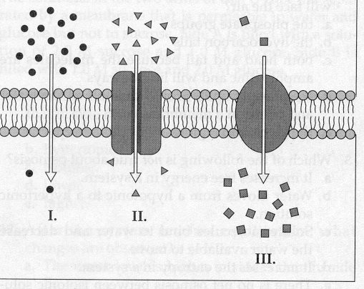
- Describe the types of transport seen here.

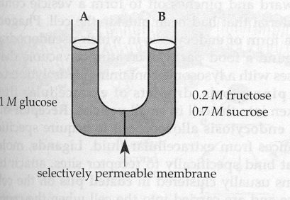

- Assume that monosaccharides are permeable. Which side is hypertonic and which is hypotonic? Which way will water diffuse? At equilibrium, what will Ψ be? Why won’t the two sides be isotonic?

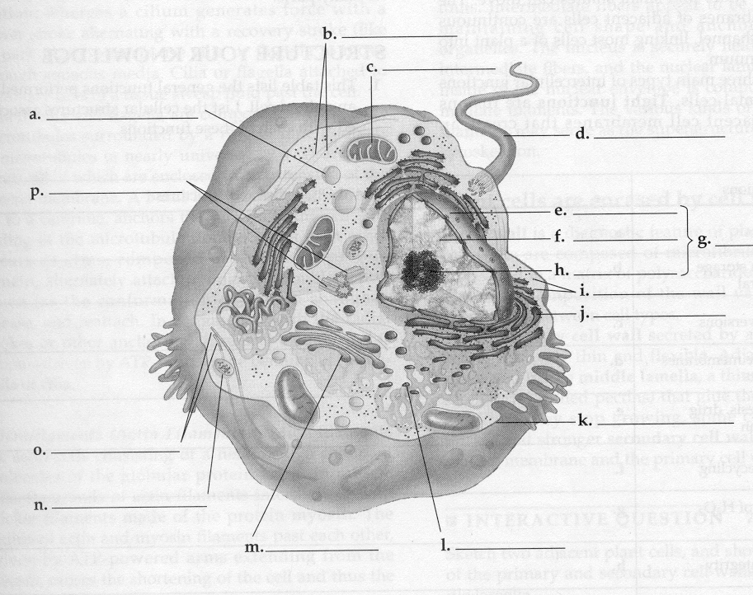
- Label the cell and include functions.

- What factors limit cell size?

- What are the major stages of the cell cycle?
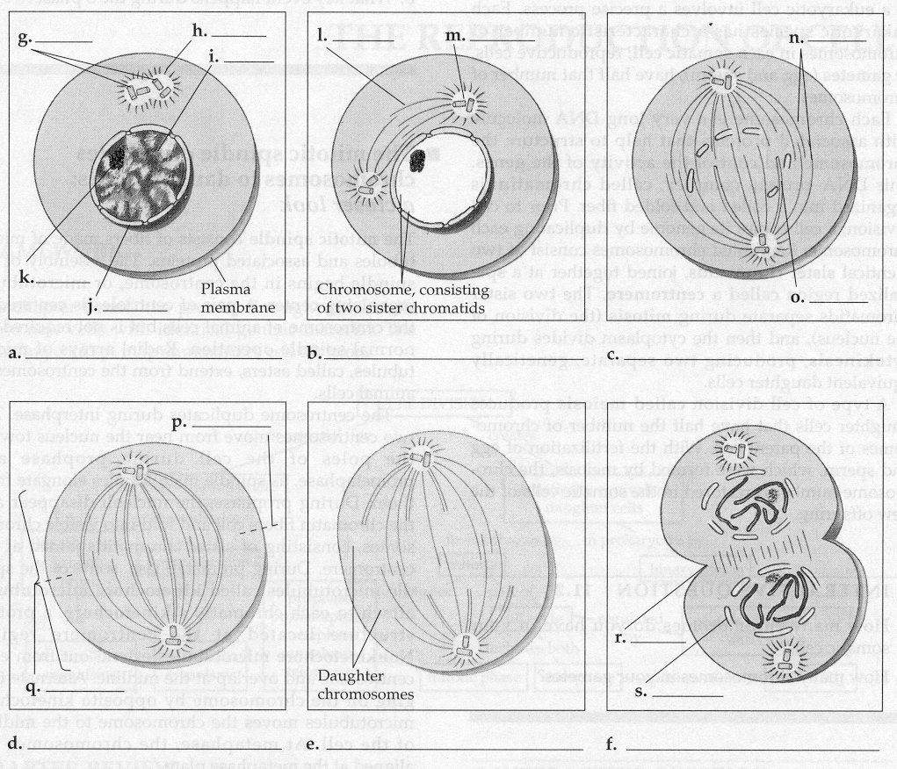

- Identify the stages of mitosis.

- What are the mechanisms of cytokinesis?

- How does mitosis differ in plants and animals?

- Describe the roll of cyclins/CDKs in regulating the cell cycle.

- What are tumor-suppressor genes and proto-oncogenes and what can happen if they are mutated?

- What features of meiosis are important in sexual reproduction?
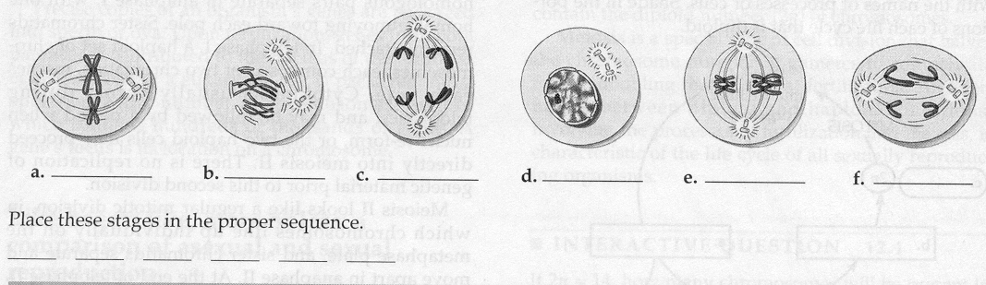

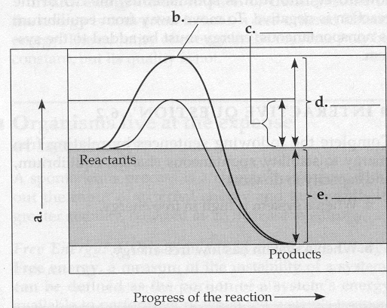
Review 2

- What are the laws of thermodynamics and how do they relate to living systems?

- How do enzymes regulate the rate of chemical reactions?

- Describe the structure of an enzyme.

- What is the induced-fit model of enzyme activity?

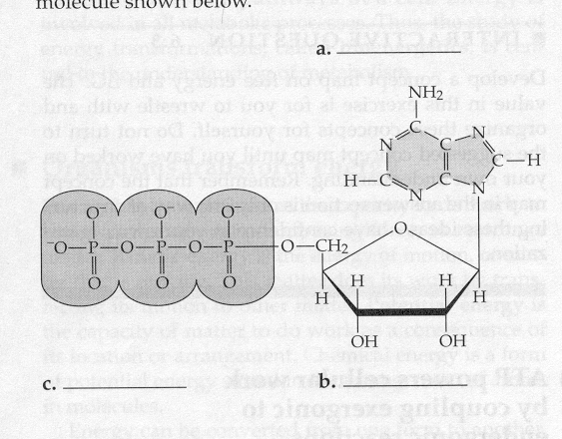
- How is the activity of an enzyme regulated?

- What is the role of ATP in coupling the cell’s anabolic and catabolic processes?

- What are two types of fermentation and what are the cells that perform each type?
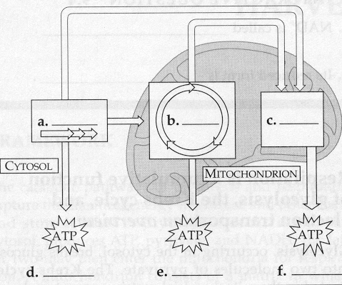

- Name the three major stages in cellular respiration.

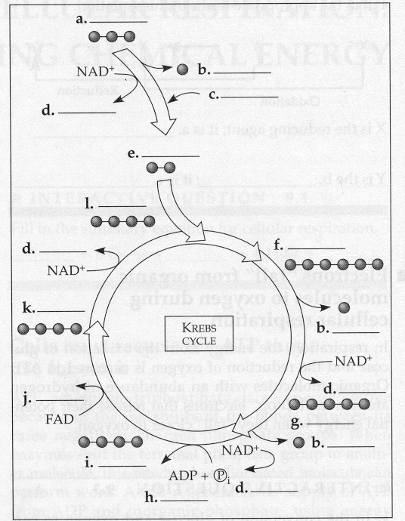

- Where does the Krebs cycle take place?

- What are the final products of the Krebs cycle?

- How many turns of the Krebs cycle are needed to oxidize 1 glucose?

- Where is the electron transport chain found?

- What is another name for oxidative phosphorylation?

- What provides the energy to drive chemiosmosis?

- Can plants do cellular respiration? Can prokaryotes?
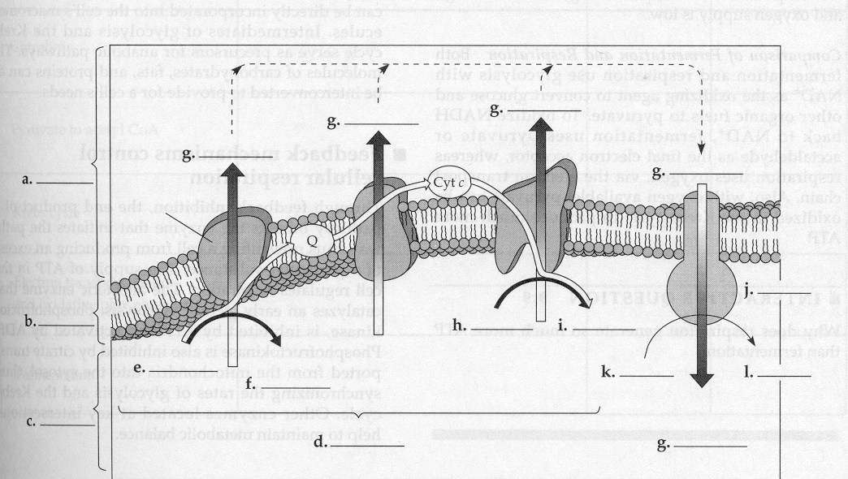

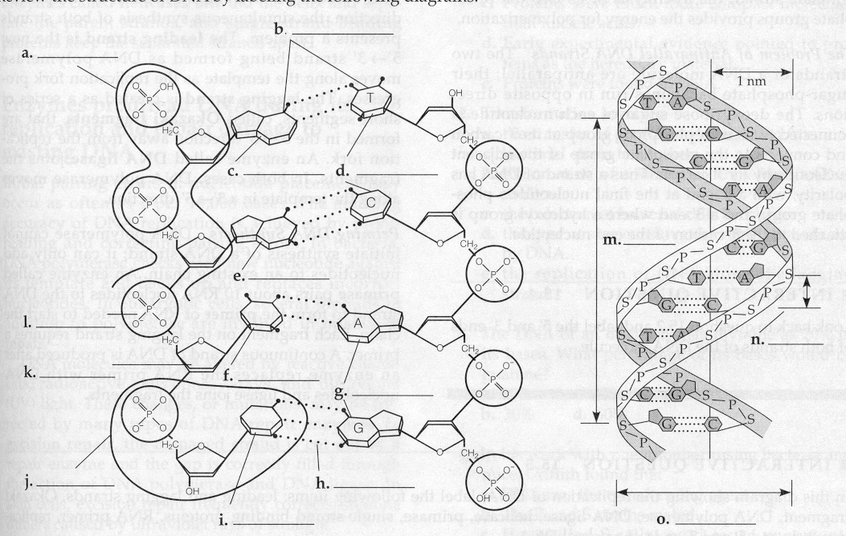
Review 3

- How do the structures of nucleic acids relate to their functions of information storage and protein synthesis?

- Compare and contrast Prokaryote Eukaryote
prokaryotic and eukaryotic
genomes.

- When does DNA replication occur?

- Who discovered the structure of DNA?
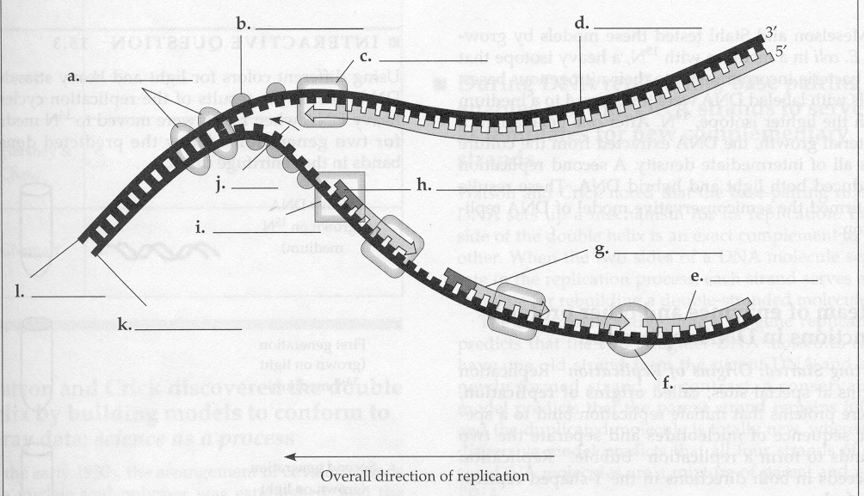

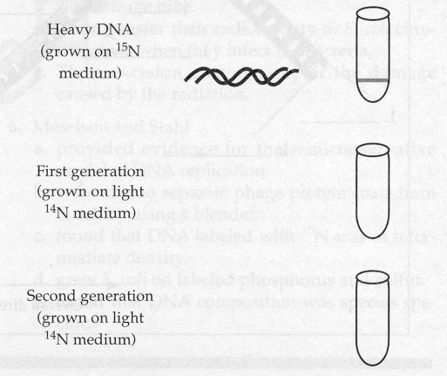
- Describe Meselson and Stahl’s experiment. What did they demonstrate?

- Complete this diagram.

- What are some of the ways that gene expression is regulated in eukaryotes?

- What are ways that gene expression is regulated in prokaryotes?

- Name some different kinds of mutations.

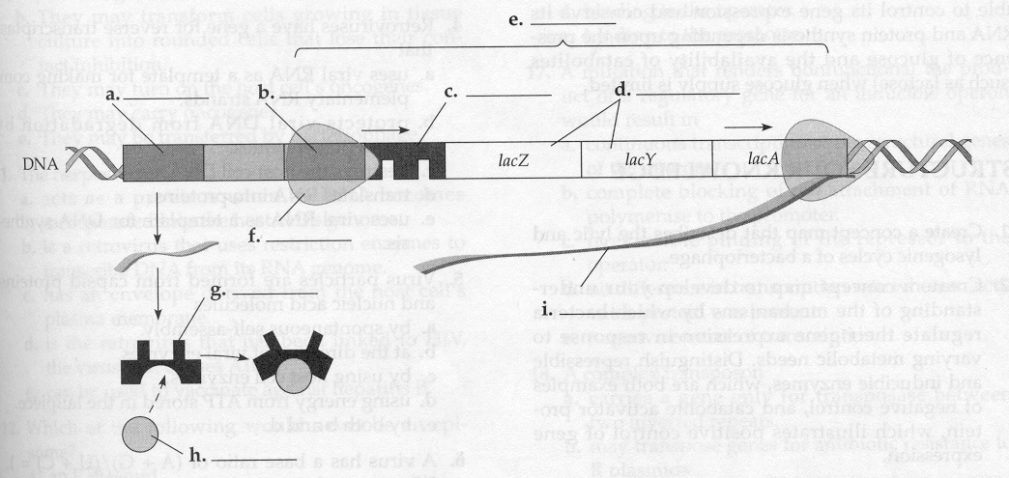
- What is Crick’s “Central Dogma” and how can we modify it?

- Where does transcription take place?

- Describe what post-transcriptional modifications take place in eukaryotes.

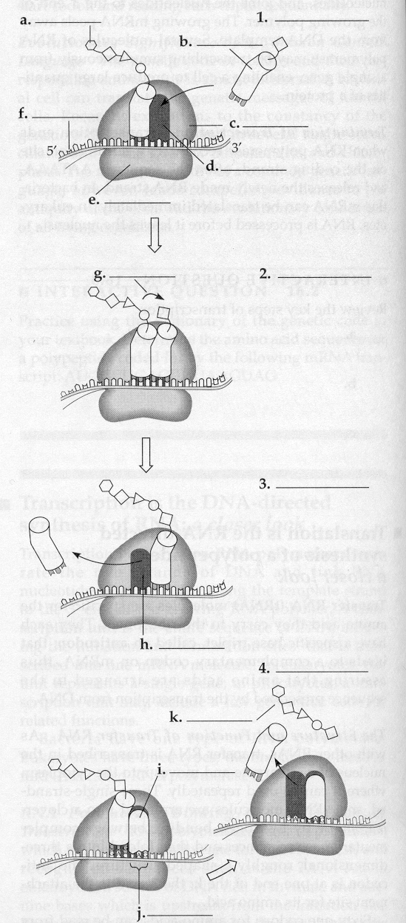
- Where does translation take place?

- Describe the basic structure of a virus.

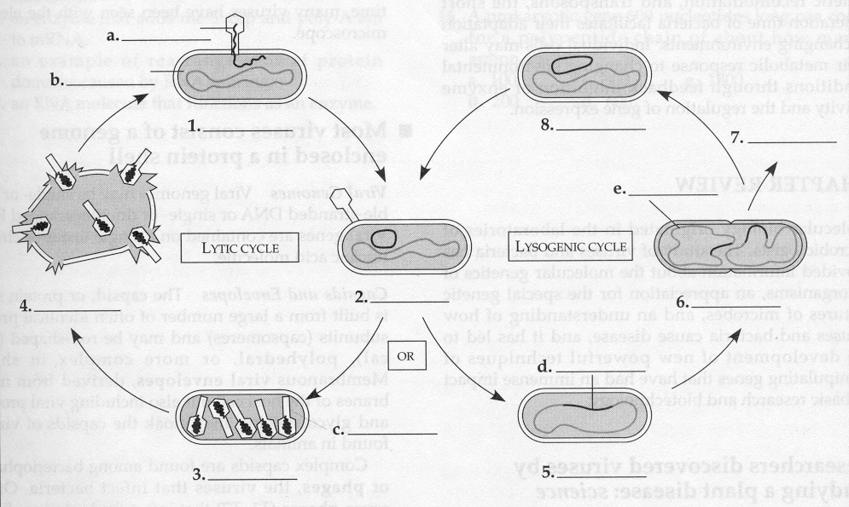

- How do viruses transfer genetic material between hosts?

- How do bacteria transfer genetic material between themselves?

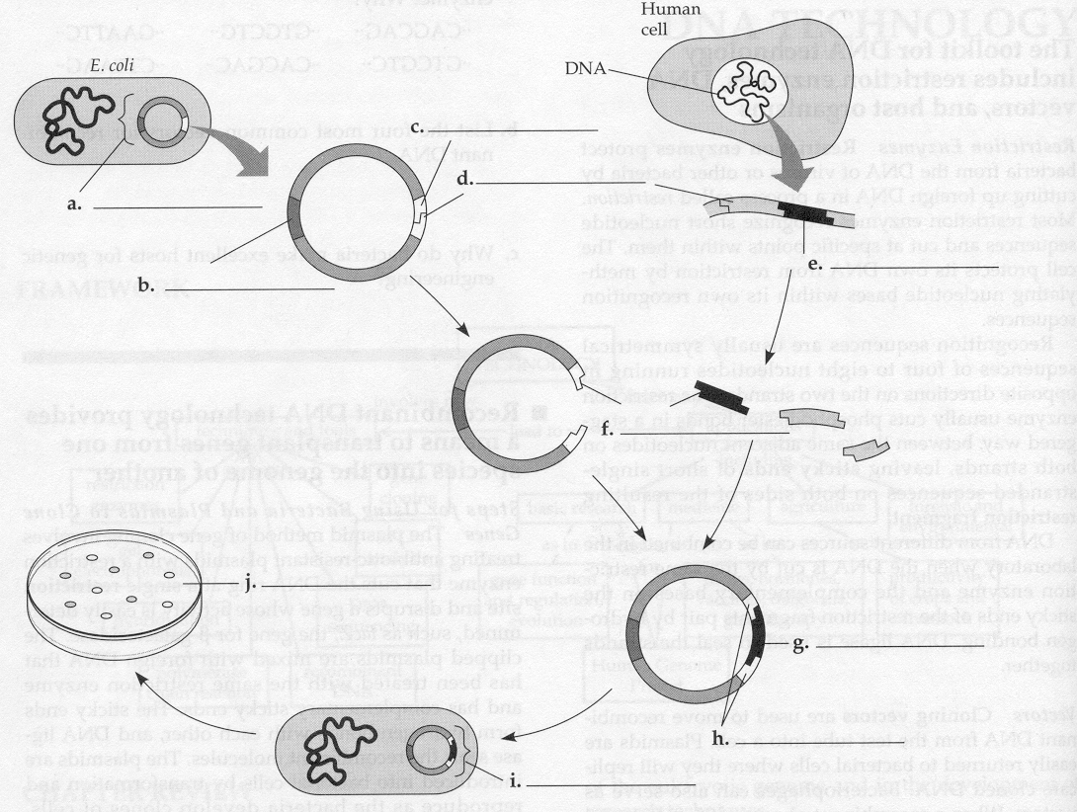

Review 4

- What are some practical applications of DNA technology?
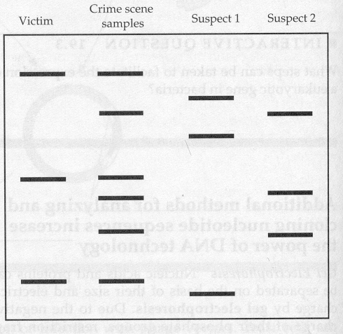

- What is a “transgenetic” organism?

- Name two separation techniques that we did in lab.

- What 2 enzymes are needed to make recombinant DNA?

- Review how gel electrophoresis works. Label the positive and negative poles on this “gel.” Label where the wells would have been. Label the smallest fragment. How does a Southern blot work?

- During our transformation experiment, what 2 things did we do to our bacteria to make it more competent? How did we select for the transformants?

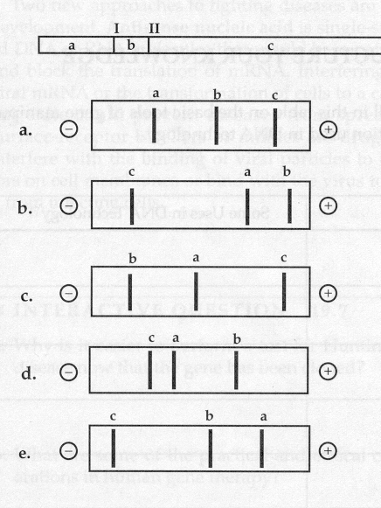
- If I and II indicate where the DNA is digested, which of the following patterns would be obtained from gel electrophoresis?

- When would you use a polyacrylamide gel (instead of an agarose gel)?

- Describe the structure and organization of a eukaryotic chromosome.

- Define the following terms: heterochromatin, euchromatin, chromosome puff, telomere and telomerase.

- Draw a pair of homologous chromosomes as seen during mitotic prophase and show two linked genes, A and B of a trans-dihybrid.

- What are Mendel’s 3 principles?

- If two heterozygotes for tall (T) and green (G) are crossed, what fraction of the offspring are likely to be short and purple (both recessive, and assume no linkage).

- Define epistasis, pleiotropic, polygenic, codominant, and incomplete dominance.

- If genes A and B are linked and the results of the cross AaBb x aabb are: 450 Ab, 460 aB, 25 AB, and 30 ab, then how far apart are genes A and B? Is the first parent a trans-dihybrid or a cis-dihybrid?

- For each of the following disorders or conditions identify whether it is caused by an autosomal (A) or sex-linked (S) single gene that is dominant (D), recessive (R) or codominant (CO), or by a chromosomal deletion (CD), inversion (CI), translocation (CT), or non-disjunction (NJ).

PKU
Klinefelter’s
Sickle-cell
Hemophelia
Down Syndrome
Cystic fibrosis
Huntington’s
Turners
Cri-du-chat
Prader-Willi
Color-blindness
Muscular dystrophy
Achondroplastic dwarfism

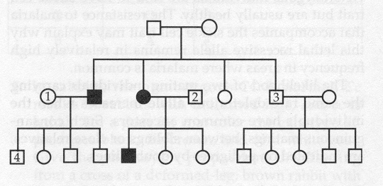
- Is the trait shown in the pedigree dominant or recessive? Using the letter “A” identify the genotypes of persons 1-4.

- What is the probability that the unmarried sister in the middle generation is actually heterozygous?

