Lipid Notes

- Fats, oils, waxes, steroids

- Nonpolar

- Not polymers

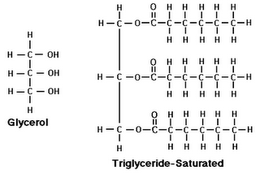
Triglycerides

- Glycerol + 3 Fatty acids

- Fatty acids have a carboxyl group and

Long C-H chain

- Fatty acids may be saturated or unsaturated

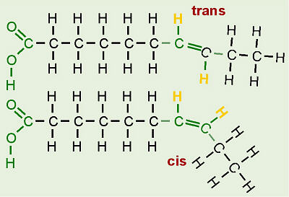
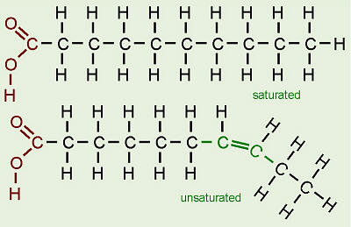

Phospholipids

- Glycerol + 2 Fatty Acids + Phosphate Functional Group

- Major component of the cell membrane

- Amphipathic
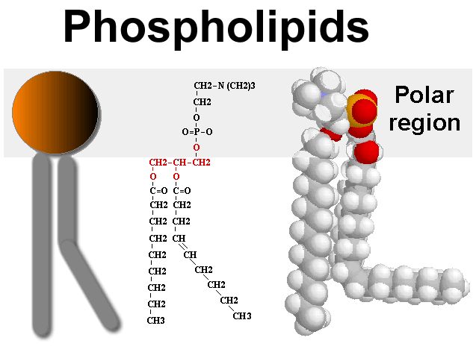

Steroids
- Basic 4 ring structure

- Cholesterol-found in cell membrane

- Other examples: testosterone, estrogen, progesterone
