Chapter 5: pp. 77-85
- List at least 4 different roles of proteins.________________________________
________________________________________________________________
- How many kinds of amino acids are there?_____________________________
- Label the five basic parts of an amino acid.
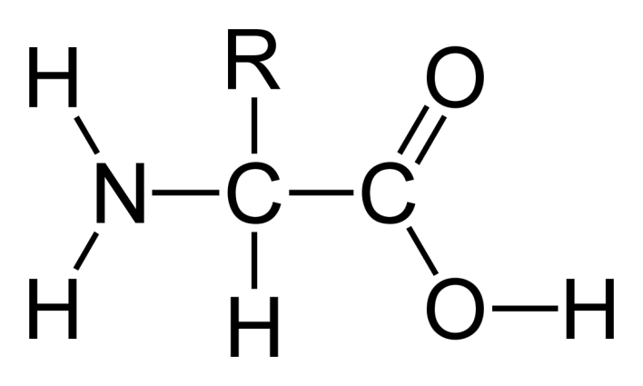

- Some side chains are polar and some are nonpolar. How can you tell the difference? _______________________________________________________
________________________________________________________________
- What kind of bond joins amino acids together in a polypeptide?
________________________________________________________________
- Who determined the sequence of the first protein? ________________________
- Explain what the primary structure of a protein is: _________________________
________________________________________________________________
- What role do genes play in the primary structure of a protein? _______________
________________________________________________________________

- Name two types of secondary structure:________________________________
________________________________________________________________
- Name four bonds that help determine tertiary structure: ____________________
________________________________________________________________
- What is the difference between tertiary and quaternary structure? ____________
________________________________________________________________
________________________________________________________________
- Define denaturation: _____ _________________________________________
________________________________________________________________

- Name two things that can denature proteins? ____________________________
- Describe the role of chaperonins: ____________________________________
________________________________________________________________

- Why haven’t scientists discovered the “rules” to protein folding by now?
________________________________________________________________
________________________________________________________________

