Polymers

Polymers form by dehydration synthesis
Polymers break down by hydrolysis

Carbohydrate Notes

- Monosaccharides

Common monosaccharides:

Glucose
Fructose
Galactose

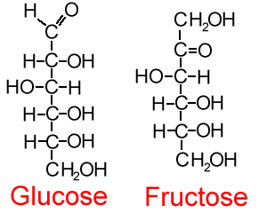

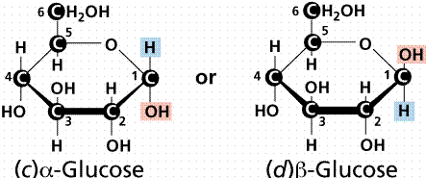

- Disaccharides

Common disaccharides:

Maltose

Lactose

Sucrose

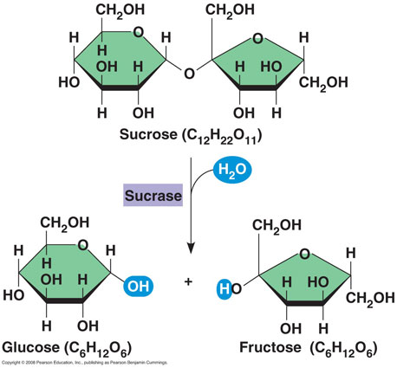

- Polysaccharides
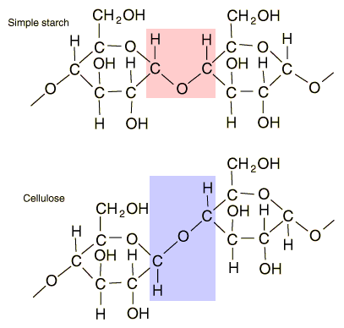
- Starch

- Glycogen

- Cellulose

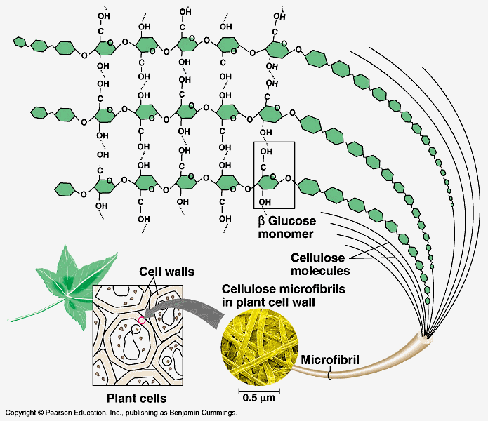

- Chitin

